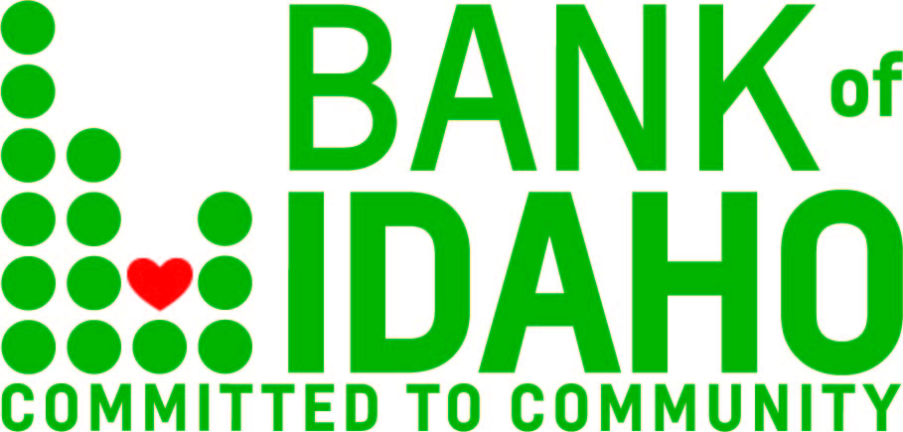
Jan. 17, 2022
Contact: Tyler Kraupp
Phone: 1.208.390.0667
tylerkraupp@bankofidaho.net

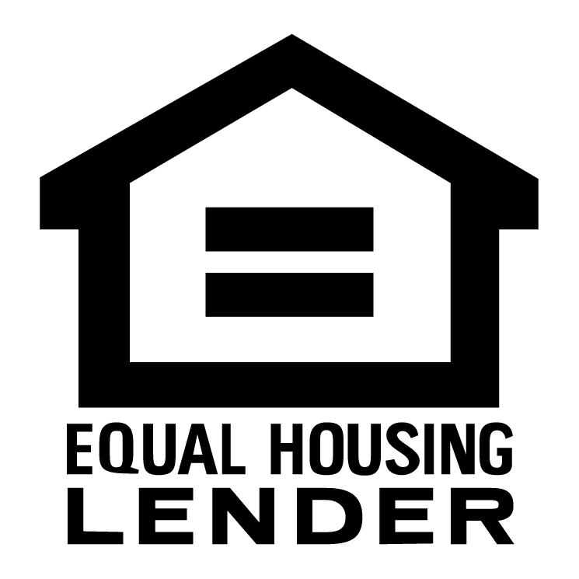
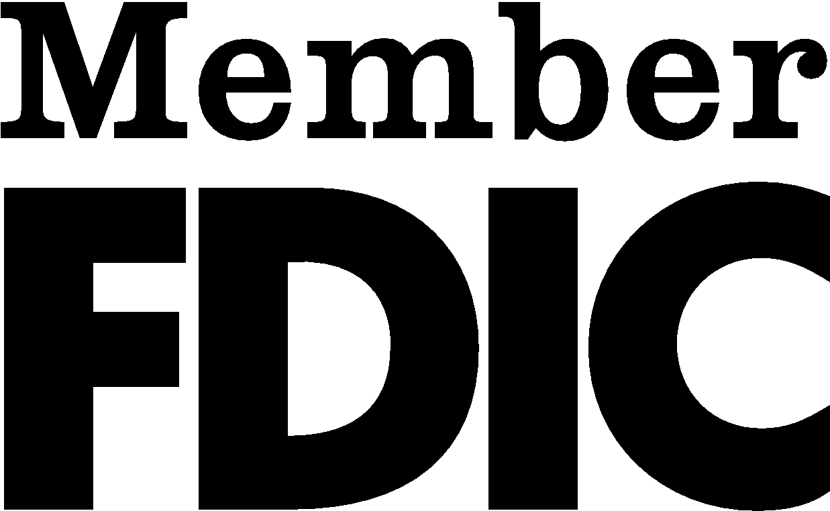

FOR IMMEDIATE RELEASE:

Bank of Idaho’s SBA lending program continues to dominate.

BOISE – Bank of Idaho’s SBA lending department continues to top state rankings, and is posed once again as the leader in the Boise District Office's top dollar-lender of Small Business Administration loans.
"Our top rank is no accident," said Bank of Idaho Vice President and SBA Department Manager Tony Vahsholtz. "It’s a sign of our commitment to Idaho’s small business owners, who are also our friends and neighbors."
In the fourth quarter of 2021, Bank of Idaho has topped its in-state peers in dollars lent, with nearly $16 million on the books, nearly a quarter of the volume in the Boise District. SBA lending can be a crucial resource for small business owners, which are Bank of Idaho's key clientele.
"Our performance in the SBA field continues to impress me and inspire our entire staff," said bank President and CEO Jeff Newgard. "And the impact they’ve had on Idaho’s small business community is just as impressive. I think it’s safe to say that we’ve established ourselves as Idaho’s go-to bank for SBA borrowers."
Bank of Idaho has been a financial fixture in the eastern Idaho community since 1985, when the original location opened in downtown Idaho Falls on the corner of Capital and B Street. Later expanding to include 10 full-service locations, and 4 mortgage offices across the state. Stock for the Bank of Idaho Holding Company opened to public trading on the OTC-QX market under the symbol BOID October 2019. With community growth always a first priority, Bank of Idaho focuses on small businesses and is a leader in SBA lending.
To learn more about Bank of Idaho's SBA offerings, go to bankofidaho.com/sba-loans.

----- END -----

